**Diet Tracker App**

The Diet Tracker App will be a basic utility program that allows a user to keep track of foods and food nutrients consumed over a period of time. The user would be able to search for food items in a database, and record the items they eat in the Diet Tracker for later reference. Food would be organized by day and meal (breakfast, lunch, diner, and snacks), and a running nutrient totals could be calculated for various periods (ie. calories per day, grams of fat per meal, carbohydrates per serving etc.). User's could view and edit the food/nutrient information for the current day, or search for and edit the information in the past.

The Diet Tracker could also provide some extended services if time and resources allow:

* **Multiuser functionality**. Diet Tracker could keep track of multiple users & multiple user histories.
* **Exercise tracking.** Diet Tracker could log exercise as well as food. The user could search a database of exercises, select a type and duration, and the negative calorie values would be incorporated into the daily calorie totals.
* **User tracking.** The user would provide information on weight, age, and stature. The Diet Tracker could calculate their BMI and provide reports on weight loss or gain.
* **Dietary goals.** The user would be able to set a weight loss goal and Diet Tracker would provide a progress report and, possibly, a suggested daily calorie intake and/or exercise regime to achieve goal in a set time.

Below are some use case scenarios for the Diet Tracker....

Use Case Number: 1

Use Case Name: Entering food item

Description: User starts app and searches for desired food. User finds the food, selects serving size, and then records it in the proper period (day & meal).

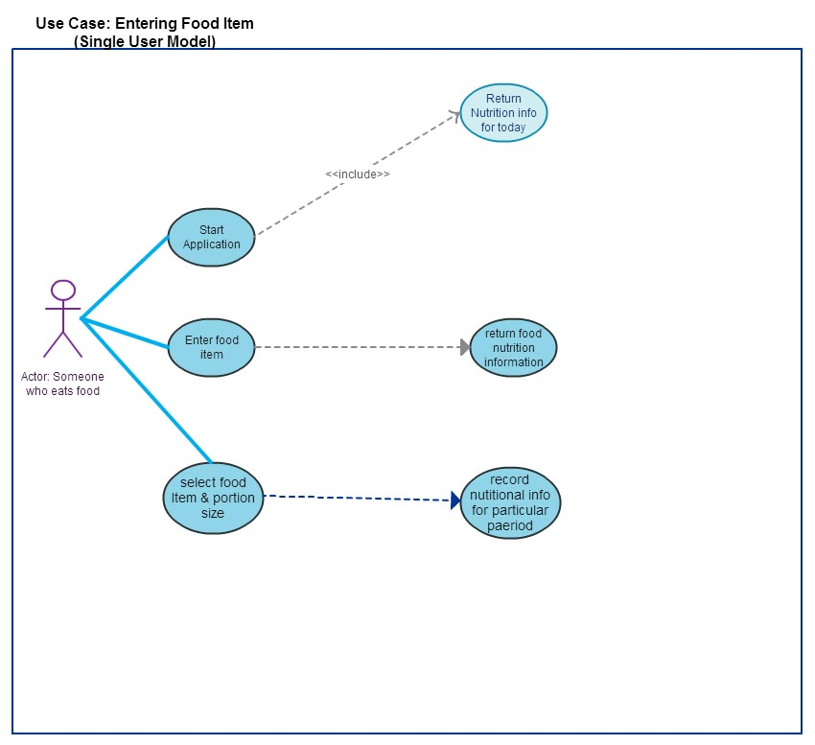

Use Case Number: 2

Use Case Name: Editing food item

Description: User starts app and navigates too previous time period (day before, week before, etc..). The user deletes a food item and replaces it with a different food item.

